Childcare Directory

This data was compiled by Greater Huron and Huron Preschool Partnership. This directory is provided
as a service, and we do not endorse nor inspect any of the sites listed below.
The Helpline Center can provide a list of current provider availability. Call 211 for more information.
Transportation
People’s Transit offers one-way or round trip door to door transportation for children to preschool, daycare, school, afterschool options for $2.50 one way. 605-353-0100.

Preschools

- Kingdom Kids Learning Center
Faith Alive Methodist Church
Address: 2660 Dakota Ave S, Huron, SD 57350
Phone: 605-352-8604 or 605-350-7152
Teachers: Rita Hilgedick and Kelly Wipf
Director: Kelly Wipf
“KKLC is a ministry of Faith Alive Methodist Church. It is a safe place where
children can explore, grow, and learn many aspects of life. Experiences will be
offered that stimulate your child's natural curiosity in language, literacy, art,
science, math, people, and the environment. Your child's social and emotional
development is our primary emphasis with much effort put toward his/her
physical, mental, and spiritual growth. The purpose of KKLC is to offer creative
learning experiences within a Christ-centered environment and partner with
families to lay a firm foundation upon which all future academic and life skills
are built.
All KKLC staff meet the adult/child ratio requirements, are at least 18 years old,
have the appropriate degree and/or experience for the positions they hold, are
CPR and First Aid certified, and have passed their background checks.”

- ALC Christian Learning Center
American Lutheran Church
Address: 155 4th St SE, Huron, SD 57350
Teacher-Director: Nicole Gerber
Contact info: Email: clc.alc@midconetwork.com Phone # for preschool is 605-352-8514, ext. 2
“Preschool classes are held in the morning for 3-4’s on Monday, Tuesday, Wednesday and Thursday 8:30-11:30 and the afternoon for 4-5 Pre-K’s on Monday, Tuesday, Wednesday, Thursday from 12:30-3:30. Children must be 3 or 4 by September 1 to enter their respective class. We closely follow the public school calendar. Children attending our preschool are well prepared for kindergarten.

We are Celebrating our 42nd year of ministry to preschoolers in the Huron area, The ALC/CLC is a self-supporting, non-profit agency of the American Lutheran Church in Huron. Our financial support comes from our monthly tuition, donations, and various fundraisers.

Our purpose is to provide a safe, positive, and stimulating non-denominational Christian environment that encourages growth in all areas of development: spiritual, emotional, physical, social, & intellectual. The ALC Christian Learning Center admits students of any race, color, national, and ethnic origin to all the rights, privileges, programs, and activities generally accorded or made available to students at the school. It does not discriminate on the basis of race, color, national and ethnic origin in administration of its educational policies, admissions policies, scholarship programs, and other school-administered programs.”

- Kindernook Preschool
Address: the corner of 16th Street & McClellan Drive
Teacher: Peggy Morris, 350-5692 (cell)
Board President: Sarah Rubish, 352-8231 (home) or 354-5735 (cell)
“Kindernook Preschool is a non-profit, non-parochial preschool which is operated in the classrooms and parish hall of Grace Episcopal Church. Founded in 1968, it was the first preschool to open in Huron.
Peggy Morris is Kindernook’s teacher, along with two full-time aides. The school offers a morning session on Mondays, Tuesdays, and Thursdays from 8:30 to 11:00 for children ages three and four, and an afternoon session on Mondays, Tuesdays, and Thursdays from 12:00 to 3:00 for children ages four and five. The school features an excellent teacher-to-student ratio, fantastic field trips, and lots of learning and playing time in a safe, structured environment. Class size is limited. Tuition assistance is available upon request.”

- Holy Trinity Catholic Preschool/Pre-Kindergarten
Address: 425 21st St SW, Huron, SD 57350

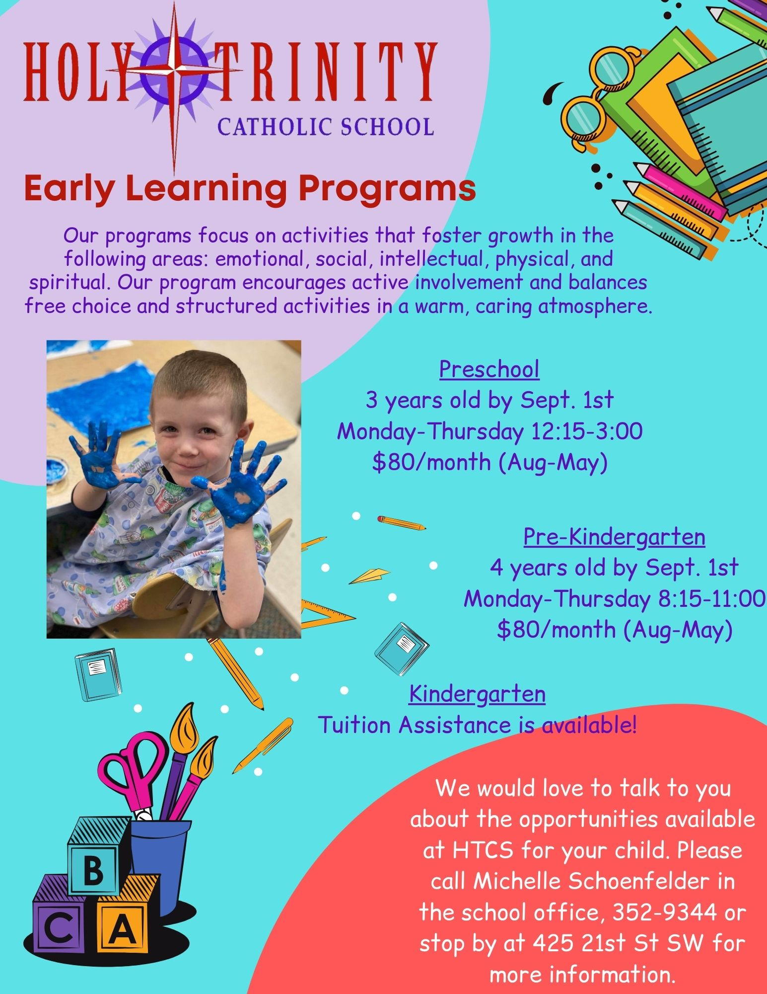

- James Valley Christian School

- Huron Head Start
Address: 135 Waibel Drive NE
Phone: 605-352-1845

- McKinley Learning Center
Address: 705 Dakota Ave. N. Huron, S.D.
Phone: 605-353-6680
Director: Ralyna Abelseth Teachers: Marisa Krekelberg, Alyssa Aker.
Ralyna.Abelseth@k12.sd.us
4-5 year old students
Mon-Thur 8:15-11:00 am
12:30-3:15 pm

Preschool/Daycare combinations

- Little Ones Playschool
Address: 556 Ohio Ave NW Huron, S.D
Phone: (605) 931-0736

“Little Ones Playschool is a child-led early education program featuring developmentally appropriate activities, learning toys, crafts and lessons for children birth through age five. Our hours are Monday through Friday 7:30 am to 4:45 pm.”

- Mt. Calvary Learning Center Preschool and Daycare
Address: 688 Dakota Ave S, Huron SD 57350
Director: Jamie Lysne
Contact info: 605-461-9222

“Every choice we make in our program is to benefit the kids and make it fun and educational for them! We have a warm and caring environment in a room perfect for learning, and upon completion of our Pre-K program your graduate will receive a personalized scrapbook from Shutterfly to commemorate the year! Our child to adult ratio is 6 to 1.”

- M & M Day Care Center
550 Mellette SW, Huron, SD
Director: Marianne Freng
Phone: 605-352-9205
Email: Mfreng.mm@hur.midco.net
A person is a person, no matter how small.- Dr Seuss’s Horton

M & M Day Care offers a full preschool program; Monday through Thursday mornings.
Our mission is to provide high quality care and education for children from infants through preschoolers.
Our center has achieved the highest level of Exemplary status by School Administrators of South Dakota Preschool Levels of Excellence.
We have also been recognized by the SDSU Quality Collaborative as a Pilot Center for the SD Quality Recognition and Information System.
Other Features:
- Infant and toddler programs for children ages 4 weeks - 3 years, PreK program for children ages 4-5 years.
- Inspiring indoor environment.
- Primary caregiving in all classrooms
- Developmentally appropriate activities per the SD Early Learning Guidelines.
- Outdoor classroom- nature rich outdoor spaces offer a time to explore art, sand, waterplay, science, music, gardening, dirt digging, gross motor activities and pretend play-all supporting children's creativity, imagination and self esteem.
- State licensed; low state required adult-child ratios. Qualified, degreed staff.
- Open M-F 6:45am -5:30pm
- Have been in business since 1970.
Daycares
- Footsteps In Growing Daycare
Jen Shaffer
507-828-0170
footstepsingrowing@gmail.com
Monday - Thursday
7:30 AM - 5:15 PM

- Teddy Bear Home Day Care
Yuri Moreno
Email: Yurib-moreno@outlook.com
Phone: 605-412-5094

- Carli’s Daycare-Carli Keefe
7:30am-5:30pm
Email: carlikeefe@gmail.com
Phone: 605-353-4621

- Ms. Stacy’s Daycare-Stacy Chaparro
Email: slchaparro2009@gmail.com
Phone: 605-354-3374

- Kristina Coss Childcare
Address: 647 Kansas Ave SE, Huron, SD 57350
Phone: 605-352-5568
“I have been in operation since 2003. I am Licensed with the State. I am also on the Food program (CACFP). I am trained in First Aid and CPR. Adult/Child Ratio follows the State guidelines. I take ages 6 weeks to 12 years.”

- Licensed Family Daycare
Darlene Sabers
Address: 1422 Wisconsin Ave SW, Huron SD 57350
Phone: 605-350-0623
A great place for your children! I have a fun, loving, learning environment with many years of experience! "We are all friends here!"
References available by request.

- Donna's Daycare
Donna Alter
Address: 477 4th Street Northeast, Huron, SD 57350
Phone: 605-350-5135

- Amanda’s Daycare
Email: abpeterson706@yahoo.com
Phone: 605-353-4935

- Little Blossom Learning Center
2660 Dakota Ave S
Huron SD 57350
605-354-2099

- LBLC BOOST afterschool and summer care
school-age children
290 7th st SW
Huron SD 57350
605-354-7918

- LBLC BOOST Friday care
school age Friday only
290 7th st SW
Huron SD 57350
605-354-7918

- Jenny Haeder
Wolsey, SD
Phone: 605-350-7182
- Family Daycare
Address: 929 Iowa Ave SE, Huron, SD 57350
Phone: 605-354-1847

- McHugh Child Care-Joann McHugh
Address: 1123 Ohio Ave. SW, Huron, SD 57350
Phone: 605-350-7966

- Mazzie Murphy
Huron, SD
Phone: 605-412-1100

- Carrie Merriam
Address: 47 4th St. NE
Email: carriemerriam@hotmail.com
Phone: 605-354-3043

- Lisa’s Day Care
Address: 443 Nebraska Ave SW, Huron, SD 57350
Phone: 605-352-5978

- Karry Borgan
Address: 1720 Utah Ave SE, Huron, SD 57350
Phone: 605-461-3367

- Marie’s Daycare
Marie Chase
Address: 1860 Riverview Drive, Huron, SD 57350
Phone: 651-592-1036

- Silvia Grohs
Address: 656 Utah Ave SE, Huron, SD 57350
Phone: 605-353-1652
Email: Kaumann49@hotmail.com

- Linda Wager
Address: 1840 Lampert Drive, Huron, SD 57350
Phone: 605-354-2402
Email: thewagers@hur.midco.net

- Happy Tots Daycare
Kristen Wiese
Address: 150 6th St. NE
Phone: 605-354-7679
Email: happytotssd@gmail.com

- Emily Aus
605-480-1353

- 5 Little Monkeys Daycare
Shani Garcia
Address: 241 Colorado Ave SW, Huron, SD 57350
Phone: 605-461-6809
Email: littlemonkeysfamilydaycare5@gmail.com

- Bridget Haider
Phone: 605-299-6737

After School Programs
- The Jungle Afterschool Program
550 Mellette SW, Huron, SD
Director: Marianne Freng
Phone: 605-352-9205
Email: Mfreng.mm@hur.midco.net
The Jungle's Out of school time program for children ages
5 through 12. The program is open before and after school,
for early release and other no school days, including a
full-day summer program, with a science focus.

- Wolsey-Wessington OST Program
Address: 375 Ash St SE, Wolsey, SD 57384
Phone: 605-883-4221

- Holy Trinity Catholic School OST
Address: 425 21st St SW, Huron, SD 57350
Phone: 605-352-9344
Email: michelle.schoenfelder@k12.sd.us

- The Salvation Army After School Program
Address:237 Illinois Ave. SW, Huron, SD 57350
Phone: 605-352-3438

- Mt. Calvary Learning Center After School Program
Address: 688 Dakota Ave. S, Huron, SD 57350
Phone: 605-412-9222

- LBLC BOOST Friday care
school age Friday only
290 7th st SW
Huron SD 57350
605-354-7918

- LBLC BOOST afterschool and summer care
school-age children
290 7th st SW
Huron SD 57350
605-354-7918

Transportation
People’s Transit offers a one-way or round trip door to door transportation option for children to preschool, school, afterschool options for $2.50 one way. 605-353-0100.

SD Dept of Social Services link to licensing information:
https://dss.sd.gov/childcare/licensing/

SD Dept of Social Services link to childcare provider search:
https://dss.sd.gov/childcare/licensing/

The Helpline Center provides up to date availability for listings on the Childcare Directory
Call 211 for more information.

